PreLoad 1.1.2 Calculator Manual

Calculator Usage:

* Calculating using standards per drink

Click Calculate!

Enter number of standard drinks per unit. Eg. 1 standard per beer

Enter Number of units in box. Eg. 24 pack

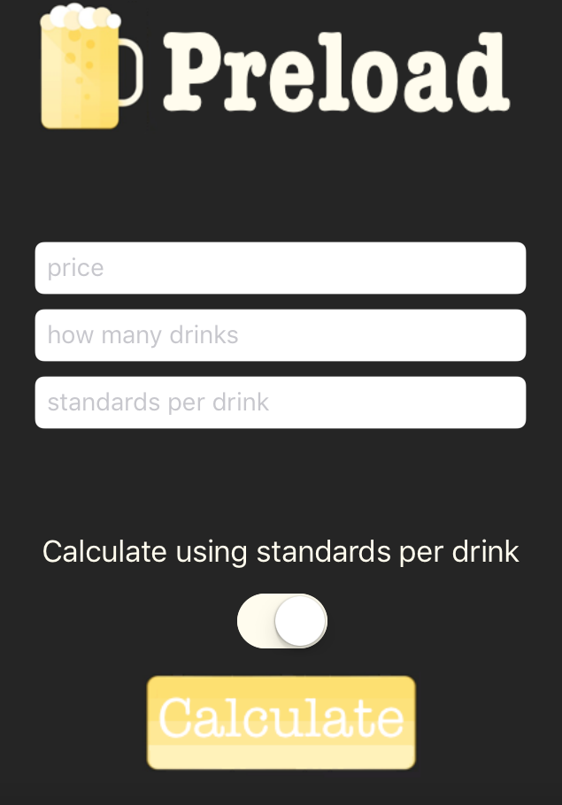

Enter Price of Beverage ($NZD). Eg. $30

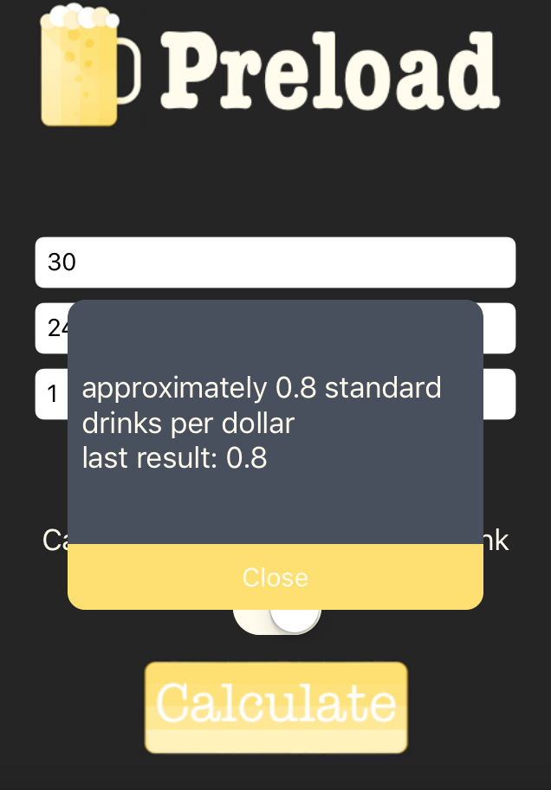

* Calculate using alcohol percentage

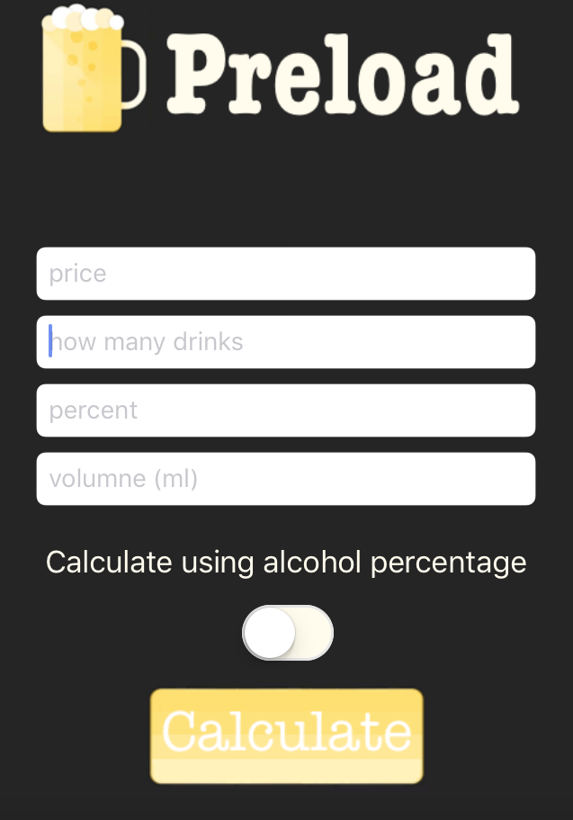

Click Calculate!

Enter number of units in box. Eg. 24

Enter volume of each individual unit. Eg. 330mL

Enter alcohol percentage of beverage. Eg 4%

Enter Price of Beverage ($NZD). Eg. $30

